# Google

Story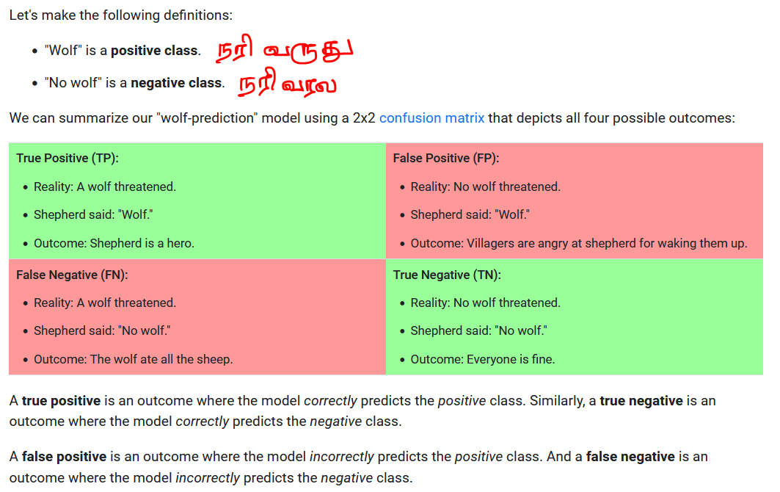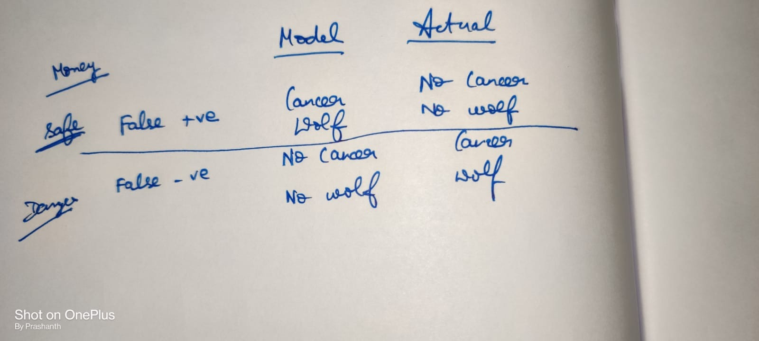

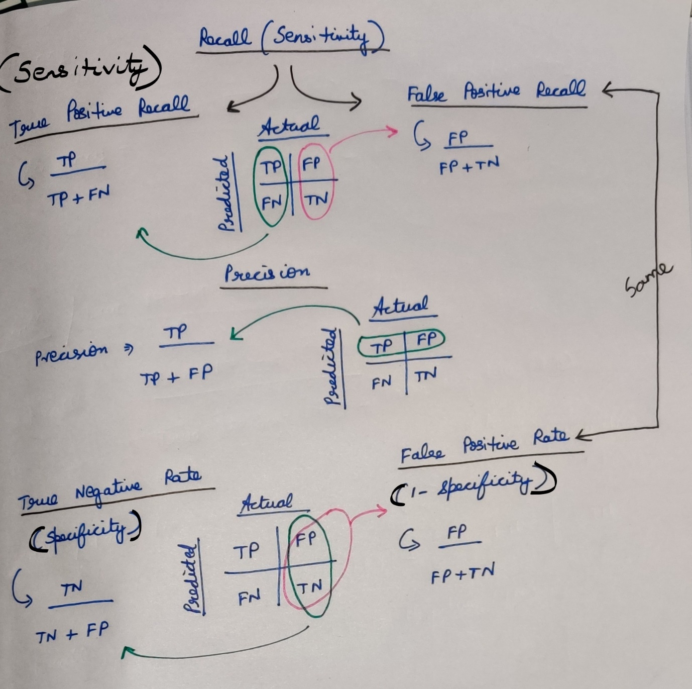

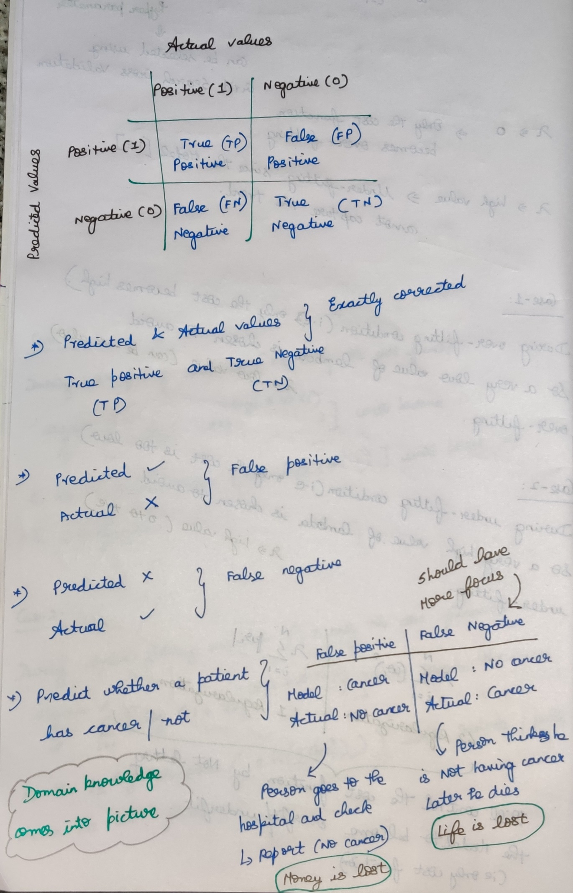

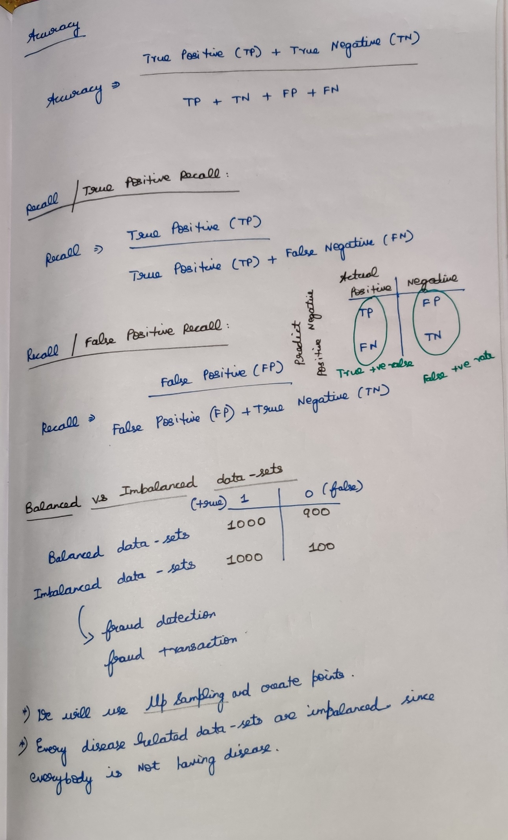

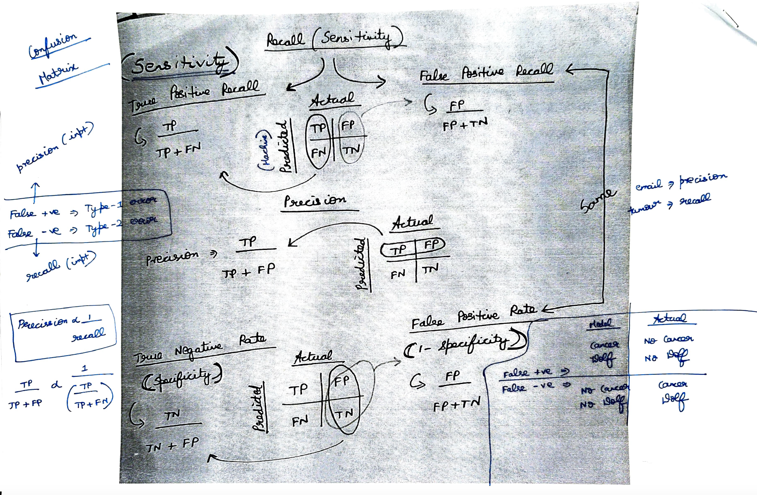

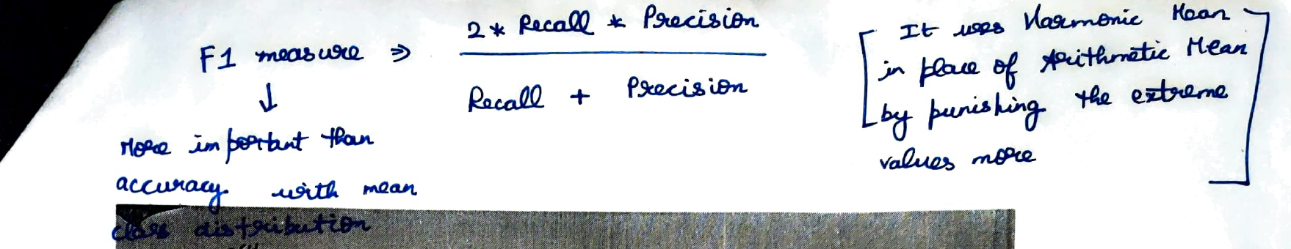

# **Precision**

*Precision is defined as the*ratio of correctly classified positive samples (True Positive) to a total number of classified positive samples*(either correctly or incorrectly).*

# **Recall**

# The recall is calculated as the ratio between the numbers of Positive samples correctly classified as Positive to the total number of Positive samples. The **recall measures the model's ability to detect positive samples**. The higher the recall, the more positive samples detected.

**Statistical Power**Statistical power, or the power of a hypothesis test is the probability that the test correctly rejects the null hypothesis.  
More intuitively, the statistical power can be thought of as the probability of accepting an alternative hypothesis, when the alternative hypothesis is true.

# **True Negative**

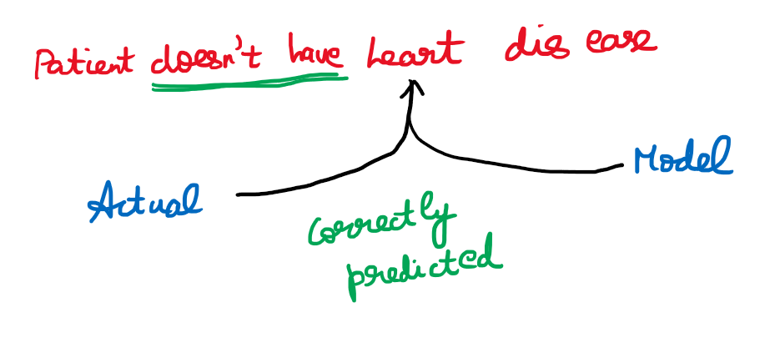

# **False Negative**

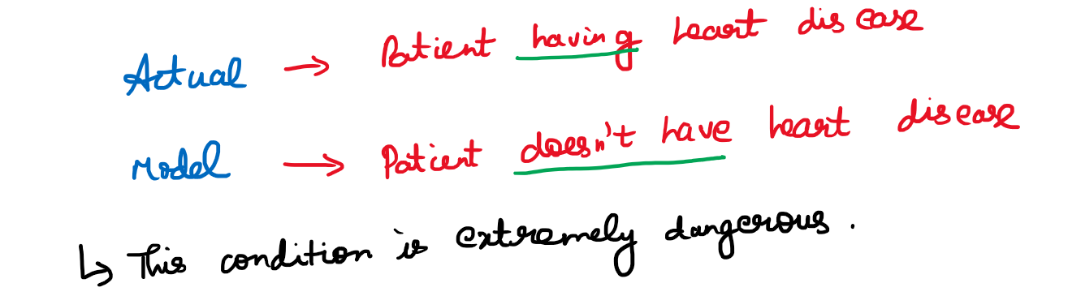

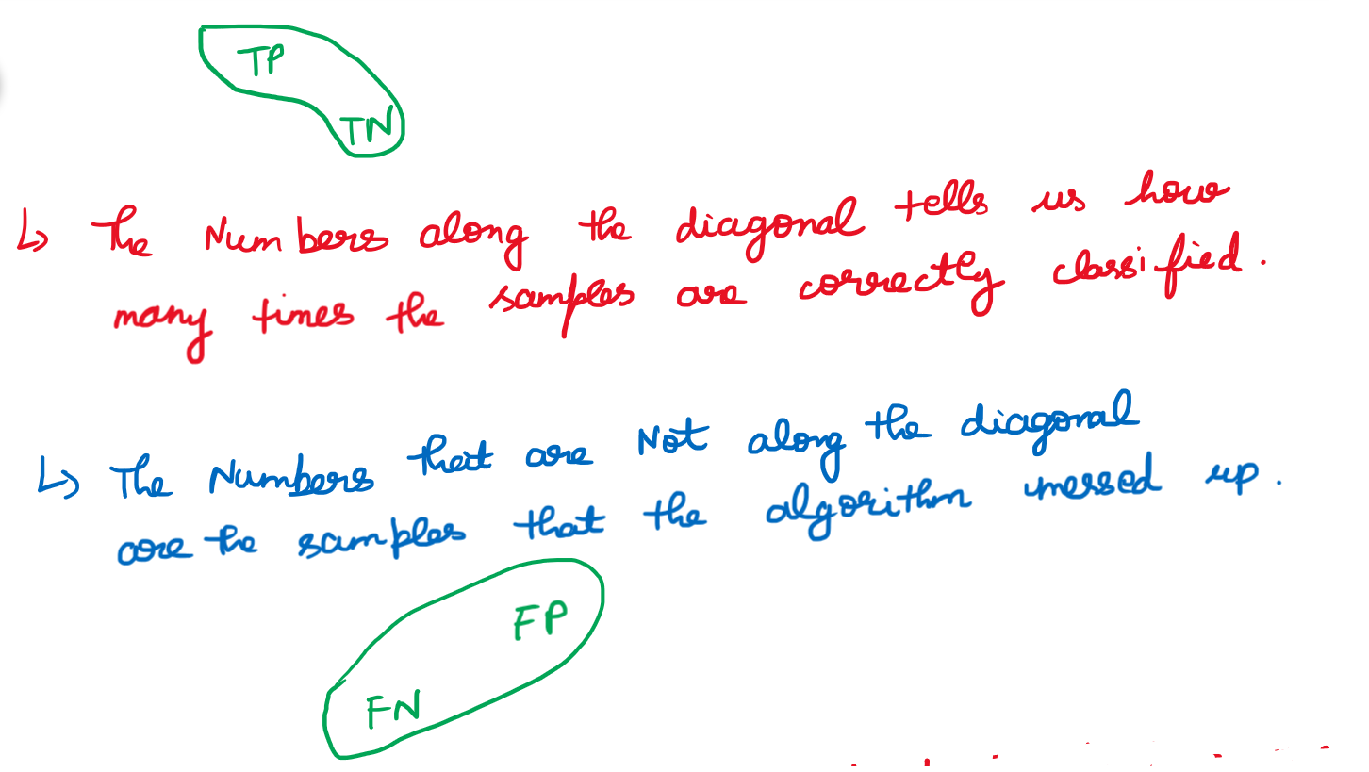

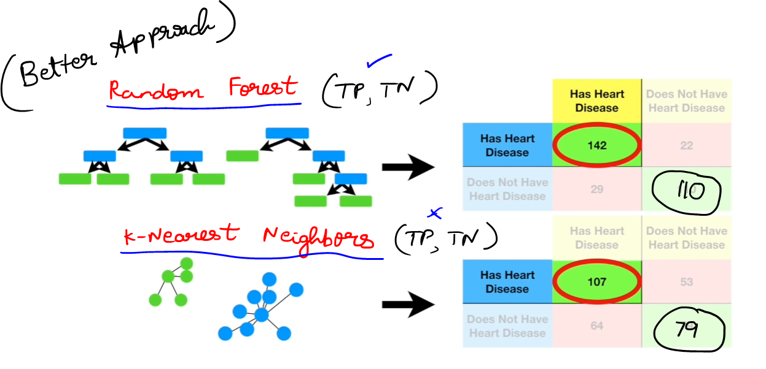

# **Sensitivity**

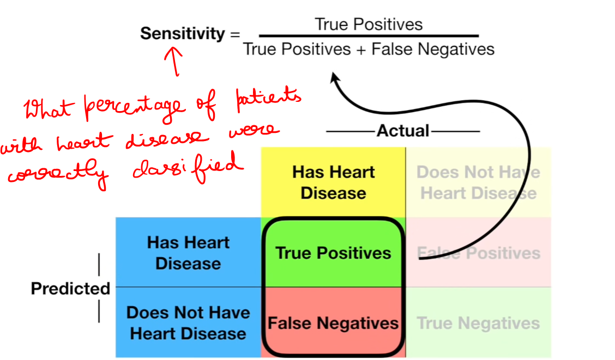

# **Specificity**

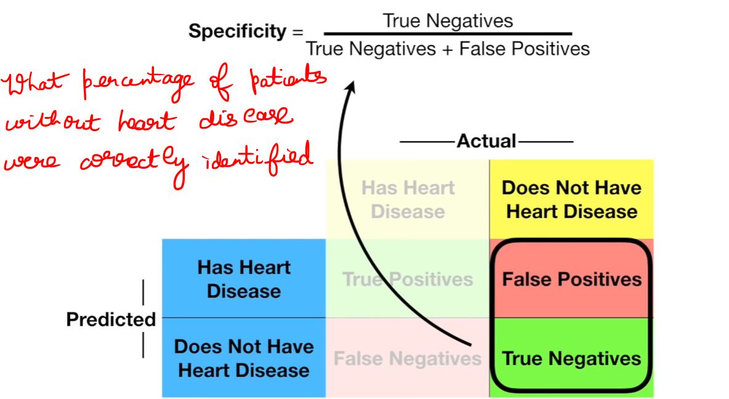

## **Logistic Regression**

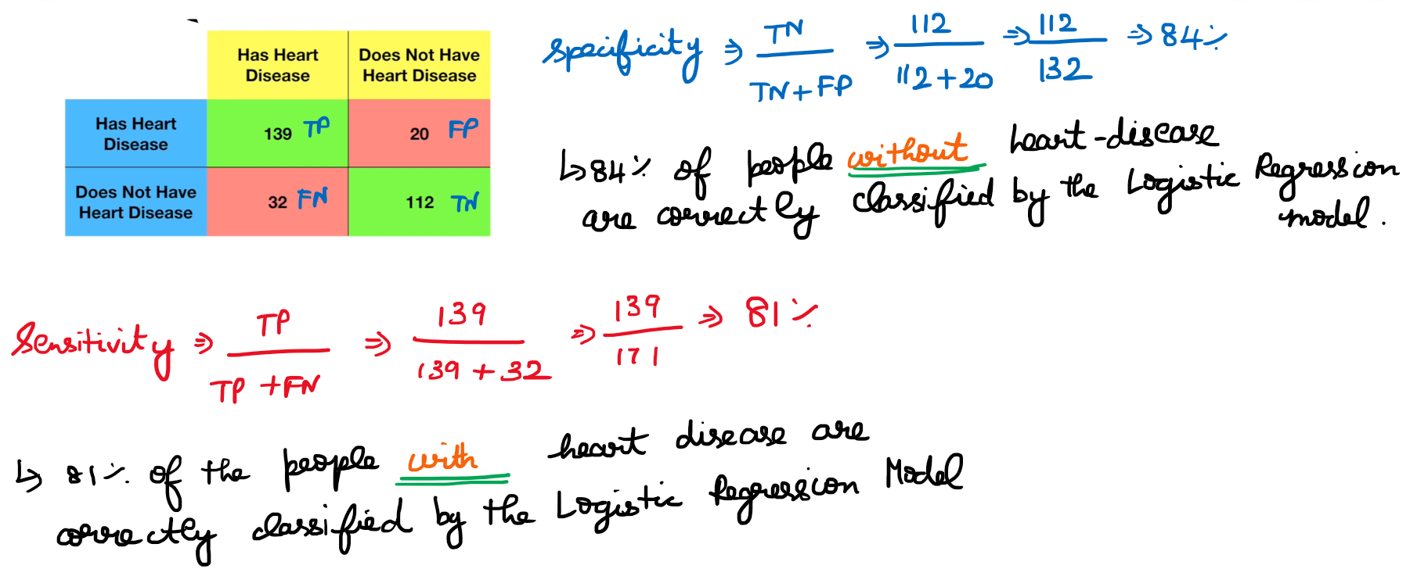

## **Random Forest**

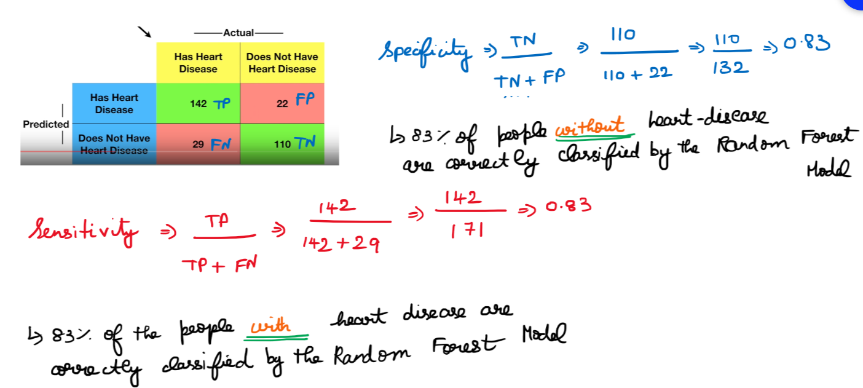

# **Comparing both the confusion matrices**

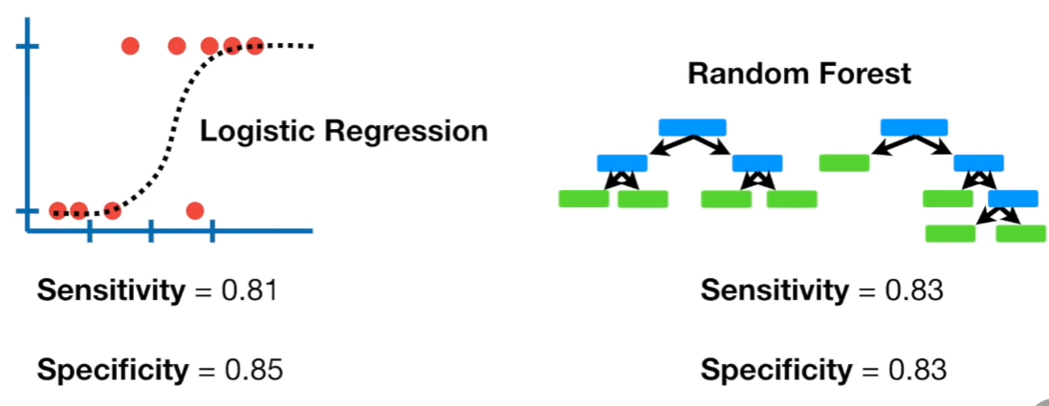

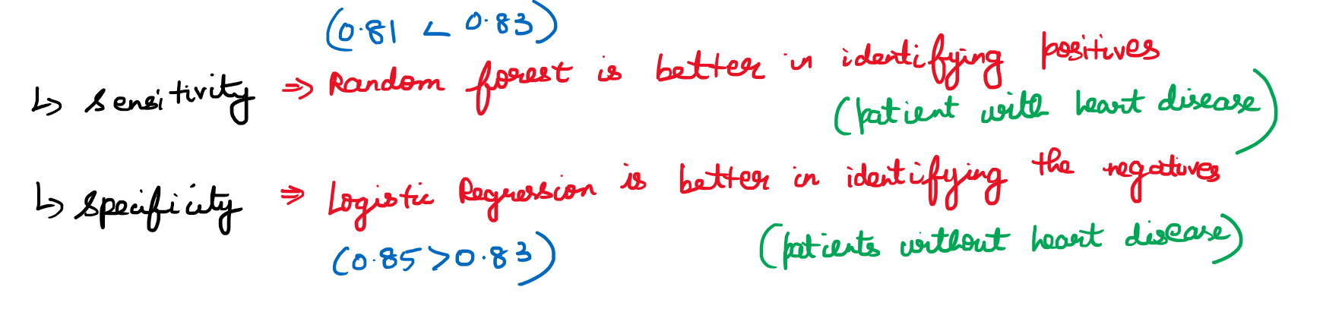

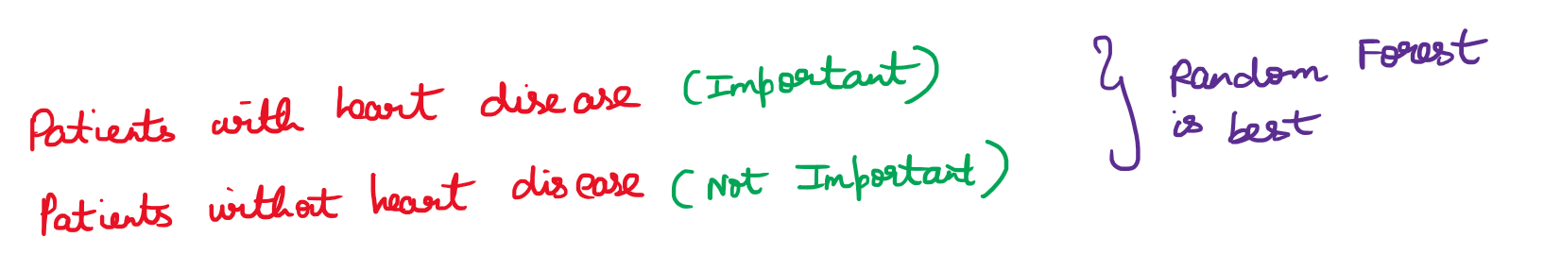

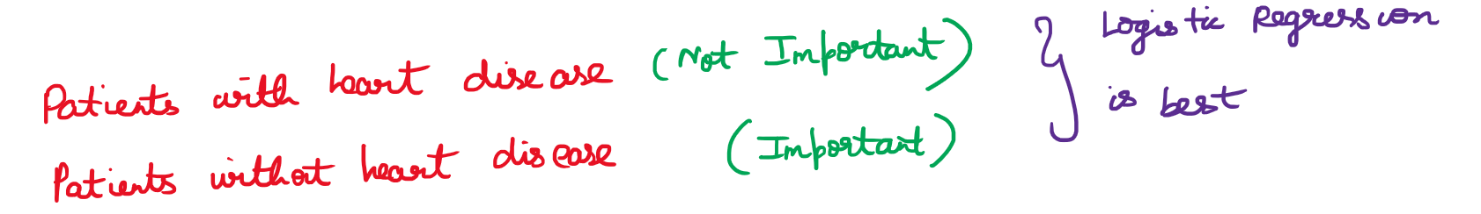

# **Final thoughts**

Spam mail detection 🡪 False Positive   
Medical 🡪 False Negative  
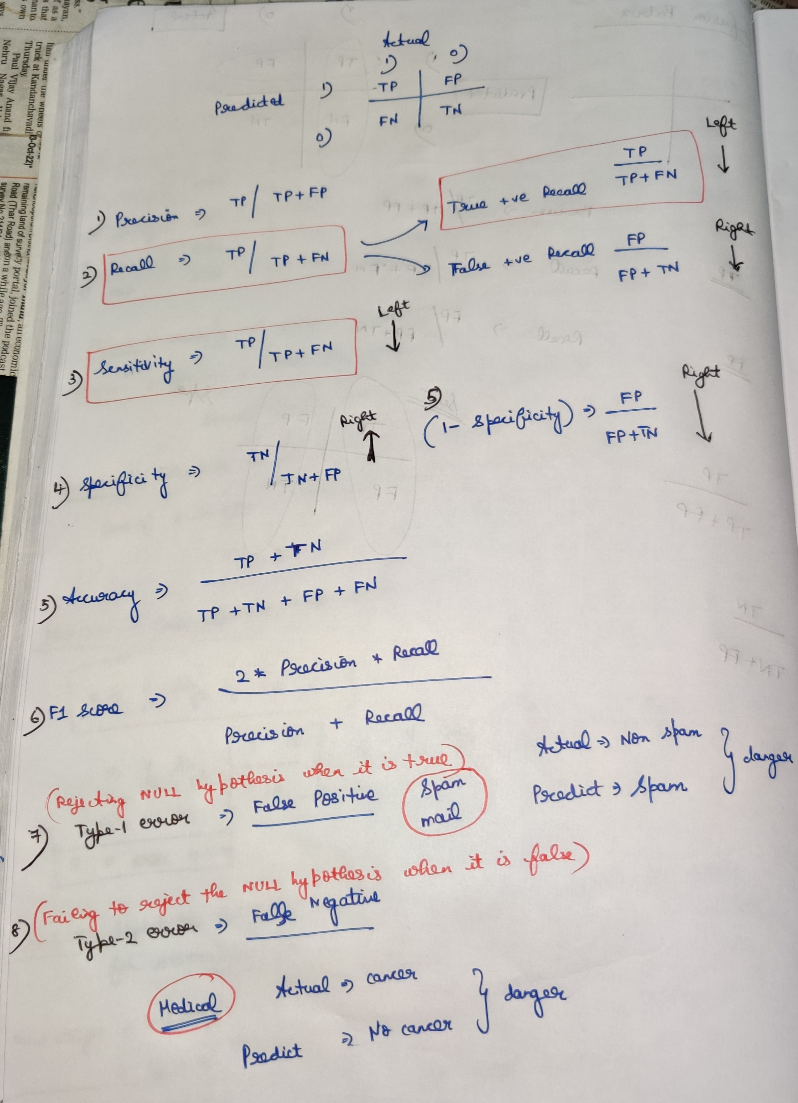

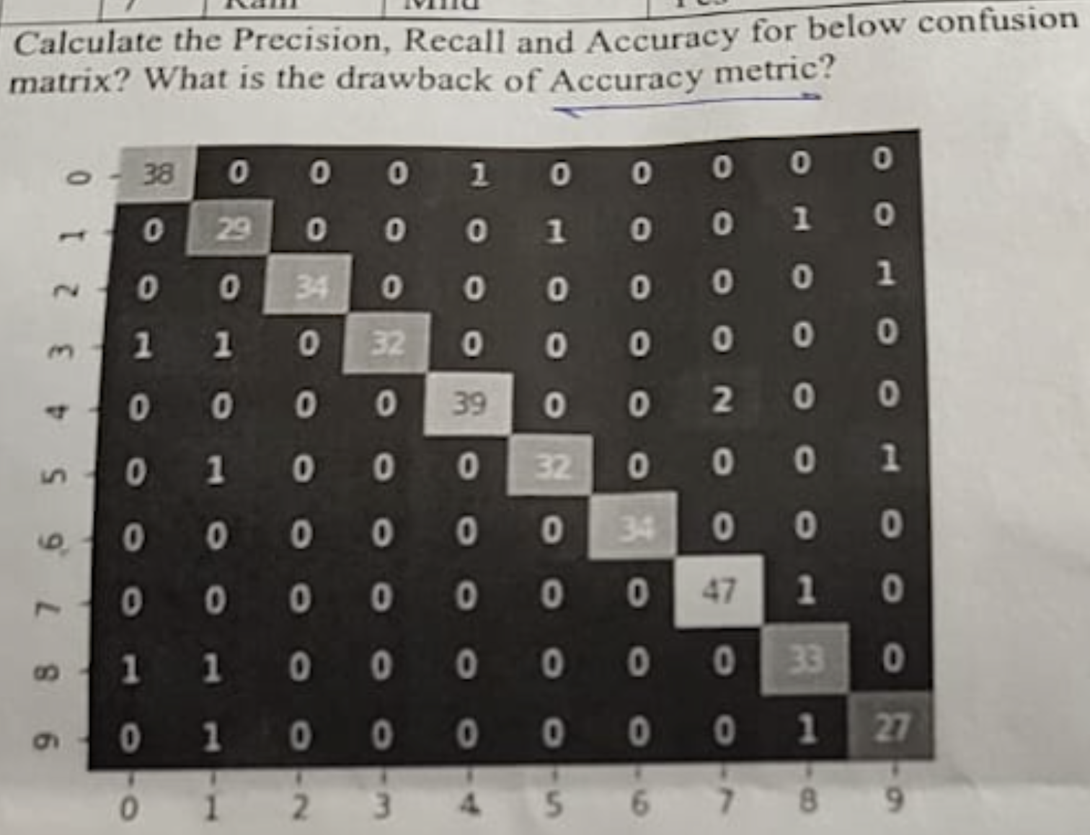



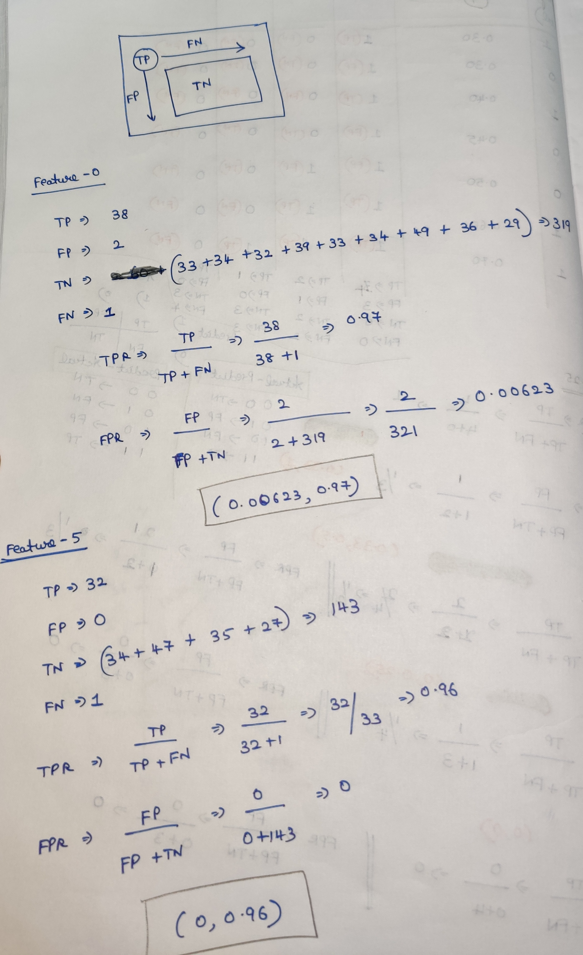

# **Area Under the Curve Problem**

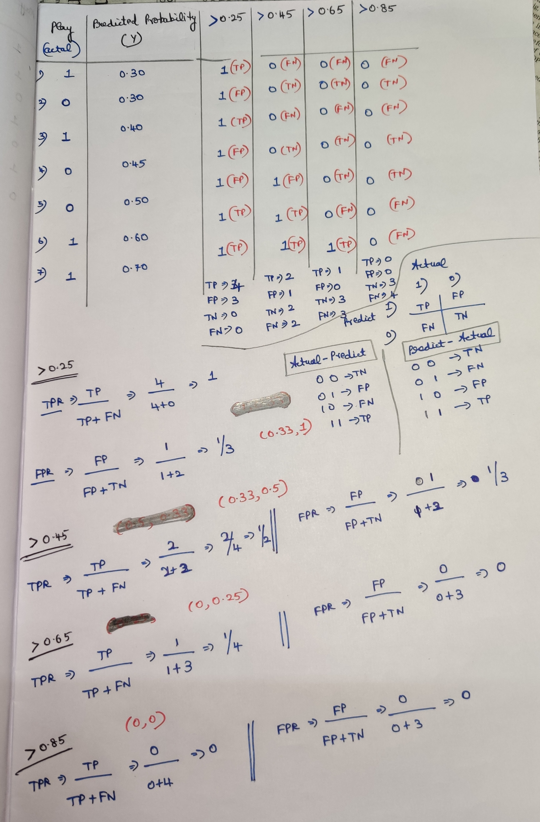

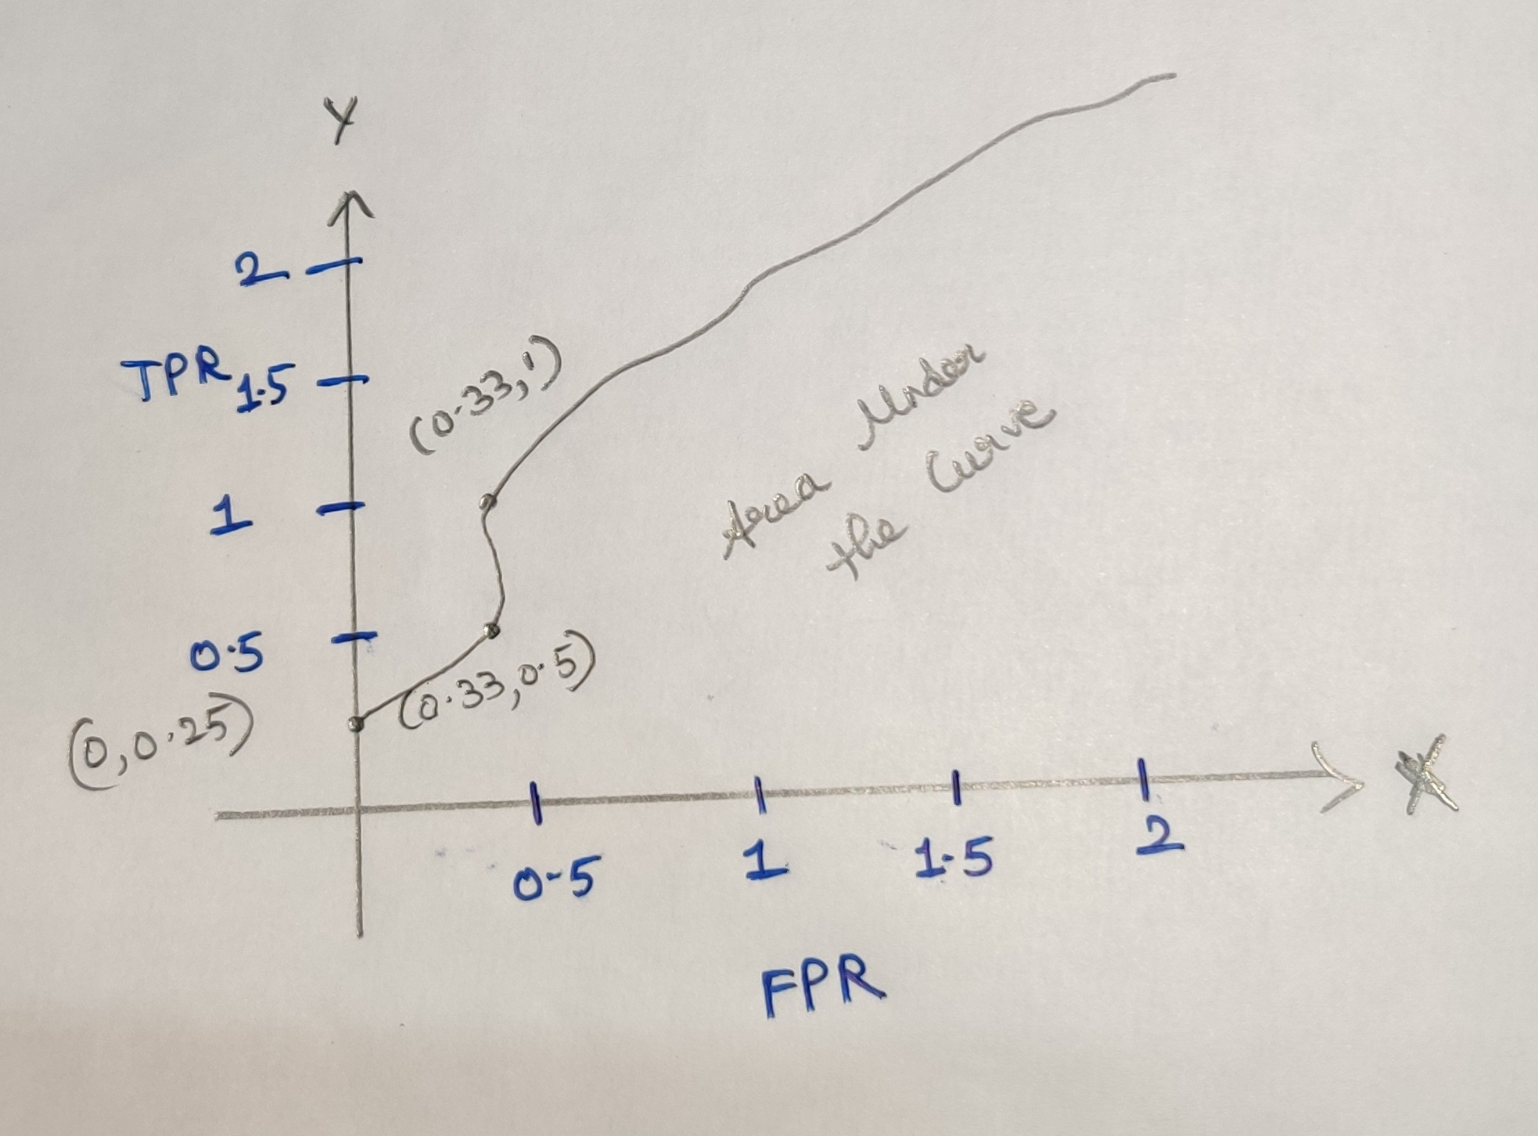

<https://developers.google.com/machine-learning/crash-course/classification/true-false-positive-negative>